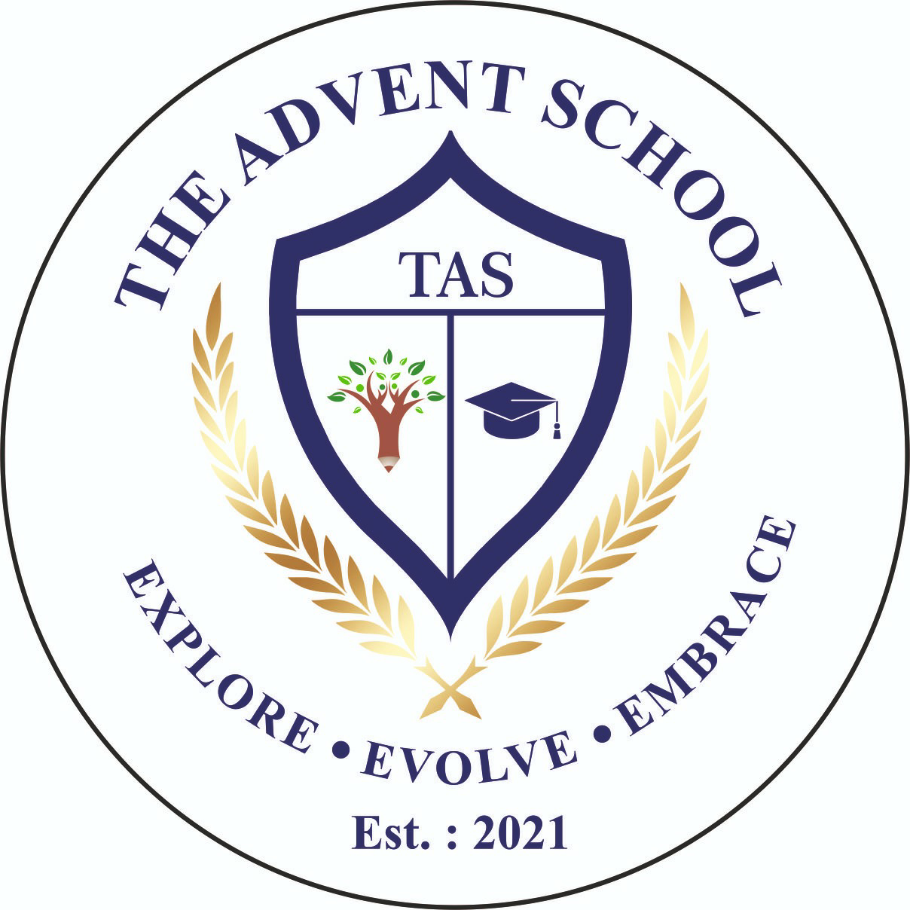
THE ADVENT SCHOOL
PRE-MID TERM ASSESSMENTS SYLLABUS
CLASS - 1
SUBJECTS | NAMES OF CHAPTERS
ENGLISH | READING  Uneen Passage  LITERATURE  Unit 1: My Family and Me  Two Little Hands  Greetings  - Dictation of New Words from chapters  GRAMMAR  Chapter 1: Nouns  Chapter 2: Common Names and Specific Names  Chapter 3: One and Many or More than One
HINDI | साहित्य  गद्यांश  इकाई1: परिवार  पाठ 1. मीना का परिवार  पाठ 2. दादा-दादी  पाठ 3. रीना का दिन  पाठ 4. रानी भी  व्याकरण  पाठ-1. भाषा  पाठ-2. वर्णमाला स्वर वर्ण  पाठ- 3. वर्णमाला व्यंजन वर्ण  पाठ- 4. मात्रा-चिह्न
MATHEMATICS | JOYFUL MATHEMATICS  Chapter 2: What is Long? What is Round?  Chapter 9: Utsav  Chapter 3: Mango Treat (Numbers 1 to 9)  Chapter 4: Making 10  Chapter 5: How Many?  ACTIVE MATHS  Chapter 1: Numbers up to 20  Chapter 2: Addition up to 20  Chapter 8: Shapes and Patterns  BRAIN POWER:  Matching (Page no. 3 to 8)  Classification (Page no. 9 to 13)  Counting 1 to 100, Table of 2 and 3, Number Names 1 to 20
EVS | Chapter 1: Myself  Chapter 2: My Body Part  Chapter 3: Sense Organs and Senses  Chapter 4: The Clothes We Wear  Chapter 5: The Food We Eat  . Diagrams – Body Parts, Sense Organs, The Clothes we wear.

NOTE: All the work done in textbook, classwork notebook and worksheets given in class groups.

